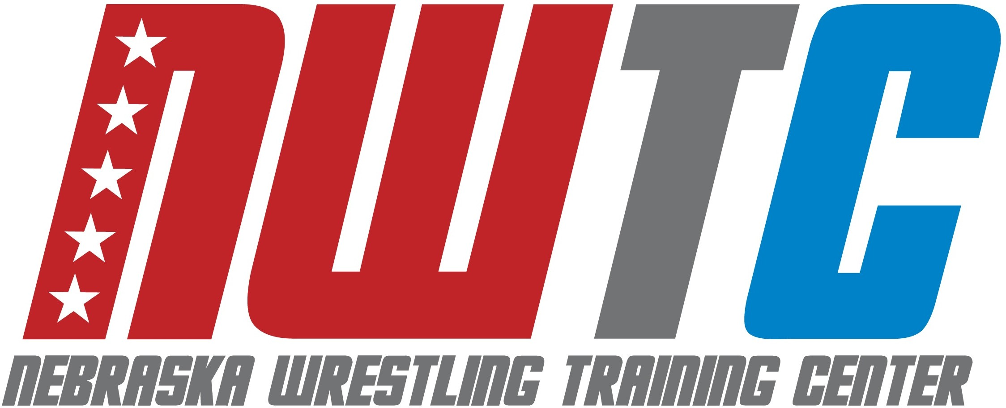

ELITE FREESTYLE CAMP SCHEDULE

**** Meet camp counselor in dorm lobby 30 minutes prior to every session ****

MONDAY, JUNE 20TH
300-430pm Check-in, Smith Hall, 1120 N 14th St., Lincoln, NE 68508
645pm Check-in, Hendricks Training Complex, 1600 Court St., Lincoln, NE 68588
700pm Technique: NU Wrestling Room

TUESDAY, JUNE 21st
630-730am Breakfast
900am Technique: NU Wrestling Room
1100-1200pm Lunch
300pm Drill + Live wrestling: NU Track
500-600pm Dinner
700pm Technique: NU Wrestling Room

WEDNESDAY, JUNE 22nd
630-730am Breakfast
900am Technique: NU Wrestling Room
1100-1200pm Lunch
300pm Drill + Live Wrestling: NU Track
500-600pm Dinner
700pm Mindset Talk – Dorm Lounge

THURSDAY, JUNE 23rd
630-730am Breakfast
900am Technique: NU Wrestling Room
1100-1200pm Lunch
300pm Drill + Live wrestling: NU Track
500-600pm Dinner
700pm Games: Memorial Stadium

FRIDAY, JUNE 24th
630-730am Breakfast
900am Technique: NU Wrestling Room
1030am Check-out

